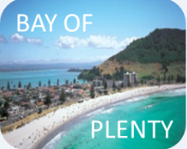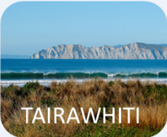

**Quarter 1**

**2022/23**

Te Manawa Taki Child Health Action Group

Quarterly Data Report

Description: Description: Description: Description: Healthshcol

|  |  |
| --- | --- |
| Completed by | Honor Lymburn  Senior Analyst  HealthShare Limited |
| Project Manager | Richard Simpson  Project Manager  HealthShare Limited |

**Contents**

1.0 Purpose 5

2.0 Te Manawa Taki 6

2.1 Our Vision 6

3.0 Hospital Services 7

4.0 Summary of Updates 8

5.0 Key messages from this report 10

6.0 Newborn Enrolment 11

6.1 Six weeks and three months of age 11

7.0 Well Child Tamariki Ora (WCTO) Indicators 12

8.0 B4 School Checks (B4SC) 13

8.1 Timeliness of B4 School Checks 14

8.2 Percentage of children who missed having first B4SC check by target age 15

8.3 Before School Checks completed by ethnicity 16

9.0 Childhood Obesity 18

10.0 Oral Health 19

10.1 B4SC results 19

10.2 Oral Health Results for Children Aged Five Years and Year 8 (CW01 & CW02) 20

11.0 Maternity Clinical Indicators 24

12.0 Maternal Smoking 25

12.1 Babies living in smokefree homes – System Level Measure (SLM) 26

12.2 Maternity Clinical Indicator: Maternal tobacco use at two weeks postnatal 27

13.0 Immunisation 29

14.0 Ambulatory Sensitive Hospitalisations (ASH) 30

APPENDICES 31

1.0 Te Manawa Taki Population and Demography 31

1.1 2021/22 Projected Population - 0-19 years 31

1.2 Projected Population Change - 0-19 years 32

2.0 Equity Gap – Worked Example 33

2.1 Which option is better? 37

2.2 Equity gap reporting demonstrates trends over time 38

2.3 Why use both absolute and relative equity measures in reporting? 40

2.4 Important – when to adjust the equity calculation: 40

3.0 Supporting data 42

3.1 B4SC Obesity definitions 42

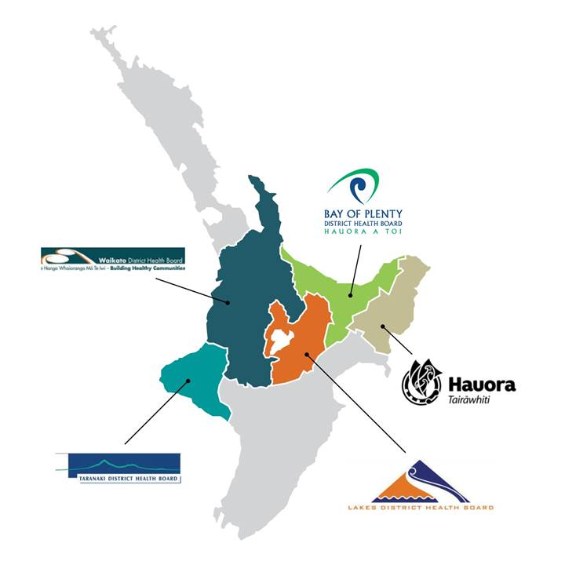**Te Manawa Taki Child Health Action Group Quarterly Report**

# Purpose

The purpose of this report is to provide information to Te Manawa Taki (TMT) Child Health Action Group (CHAG) to inform and support the work programme clinical initiatives, to achieve the network’s key objectives.

New data points will be added during the work as they are identified by the clinical network participants as useful for meeting the Regional Equity Plan (REP) initiatives.

The Q3 2017/18 report was the first report to be provided to a broader audience than the CHAG group. The intent was to provide relevant data to providers with an interest in child health, embracing trends over time, progress towards target, and equity gap comparison between Māori and Non Māori results.

This report is prepared by:

Honor Lymburn

Senior Analyst, HealthShare Limited

[Honor.Lymburn@healthshare.co.nz](mailto:Honor.Lymburn@healthshare.co.nz)

|  |  |  |  |  |
| --- | --- | --- | --- | --- |
| Bay of Plenty | Lakes | Tairāwhiti | Taranaki | Waikato |

# Te Manawa Taki

**Te Manawa Taki** (‘the heart beat’) is the name gifted and agreed upon to represent the region encompassing the five DHB regions of Bay of Plenty, Hauora Tairāwhiti, Lakes, Taranaki and Waikato. Te Manawa Taki has been gifted to us to replace the term Midland.

The name Te Manawa Taki in the context of the combined region represents:

* Always ready to go
* Without a strong heartbeat the fish cannot swim
* We lead, others follow

## Our Vision

Te Manawa Taki’s vision is *He kapa kī tahi* - a singular pursuit of Māori health equity.

It reflects that as a region we will work in unison to achieve equity of Māori health outcomes and wellbeing through multiple means, including:

* A health system that actively prioritises achieving Māori health equity.
* Mutual respect for braiding the best of kaupapa Māori and western science best practice evidence, thinking and worldviews to benefit Māori health equity.
* Shared accountability for measuring and achieving success.
* Shared decision-making and authority.
* Shared resources (financial, technical, human, other).
* Working in partnership to create a system that enables Māori to lead solutions that are based on kaupapa Māori and mātauranga Māori.
* Creating and enabling champions to lead solutions that drive equitable outcomes for Māori.

# Hospital Services

Te Manawa Taki comprises five DHBs. The hospitals in the region are broken into tertiary, secondary and primary for Child Health services.

**Tertiary hospital**

* + Waikato Hamilton

**Secondary hospitals**

* + BOP Tauranga and Whakatane
  + Taranaki Taranaki Base
  + Lakes Rotorua
  + Tairāwhiti Puawai Aroha (Gisborne)

**Primary hospitals**

* + Waikato Thames, Taumarunui, Te Kuiti, and Tokoroa
  + Taranaki Hawera
  + Lakes Taupo
  + Tairāwhiti Ngati Porou Hauora – (Te Puia Springs Hospital)

# Summary of Updates

| **Section** | **Sub section** | **New** | **Updated** | **No change** | **Notes** |
| --- | --- | --- | --- | --- | --- |
| 1. **Purpose** | * DHB Map |  |  | ü | No change |
| 1. **Te Manawa Taki** |  |  |  | ü |  |
| 1. **Hospital Services** |  |  |  | ü | No change |
| 1. **Summary of Updates** |  |  | ü |  | Updated |
| 1. **Key messages from this report** |  |  | ü |  | Summarises the results over time (rather than by quarter), will be updated as trends change |
| 1. **PHO Enrolment** | * Newborn enrolment stats for babies aged 6 weeks and 3 months |  |  | ü | Unable to update - currently seeking a new source for this information |
| 1. **WCTO Indicators** |  |  |  | ü | No change |
| 1. **Before School Checks (B4SC)** | * B4SC reports |  | ü |  | Updated to Q1 2022/23 |
| * Timeliness of B4SC checks |  | ü |  | Updated to Q1 2022/23 |
| * Children who missed having first B4SC check by 4 ½ years |  | ü |  | Updated to Q1 2022/23 |
| * B4SC checks completed by Māori/Non Māori |  | ü |  | Updated to Q1 2022/23 |
| 1. **Childhood Obesity** |  |  | ü |  | Updated to Q1 2022/23 |
| 1. **Oral Health** | * B4SC results |  | ü |  | Updated to Q1 2022/23 |
| * Aged 5 years/Year 8 |  |  | ü | No change, updated annually |
| 1. **Maternity Clinical Indicators** | * 2013-2020 |  | ü |  | Updated to 2013-2020 |
|  | * SLM – Babies living in smoke free homes |  | ü |  | Updated to six months ending June 2022 |
| * Maternity Clinical Indicator |  | ü |  | Updated to 2013-2020 |
| 1. **Immunisations** | * Quarterly and Annual results |  | ü |  | Updated to Q1 2022/23 |
| 1. **Ambulatory Sensitive Hospitalisations** |  |  | ü |  | Updated with annual results as at June. |
| **Appendices** | 1. **Te Manawa Taki Population and Demography** |  | ü |  | No change, updated annually |
|  | 1. **Equity Gap - example** |  |  | ü |  |
|  | 1. **Supporting data** |  |  |  |  |
|  | * 1. B4SC Obesity data definitions |  |  | ü |  |

# Key messages from this report

Key messages for Te Manawa Taki based on results over time:

* Māori newborn enrolments are lower than Non Māori enrolments
* Childhood immunisations at eight months, two and five years continue have dropped further away from target
* Māori children have lower immunisation rates than Non Māori children, the regional equity gap has increased over time
* Māori have higher percentages of late immunisations after each immunisation milestone. Equity gaps improve the further away children are measured from the immunisation points.
* By five years of age, the percentage of immunised Māori children are close to the percentage of Non Māori children, but this gap has been progressively widening until Q3 2021/22.
* Māori children under five years have higher obesity rates than Non Māori; Pacific children have higher obesity rates than Māori.
* In addition to results above, Te Manawa Taki Māori children have poorer Well Child Tamariki Ora results for:
  + Referrals to well child providers and all core contacts completed in first year
  + B4SC screenings started before children are 4.5 years old
  + Oral Health - enrolments with community oral health (0-4 years), children who are caries free at five years, average decayed, missing, and filled teeth at five years
  + Breastfeeding over first three months
  + Completion of family violence screening
  + Health weight at four years old
  + Child well being and resilience
* Māori mothers have poorer maternity clinical indicator results for:
  + Registration of expectant mother within the first trimester of pregnancy
  + General anaesthetic or blood transfusion required with caesarean section
  + Maternal tobacco use at two weeks post natal (also a higher rate of smoking upon registration with LMC)
  + Small babies at term and pre-term birth
* Ambulatory Sensitive Hospitalisation (ASH) rates are poorer for Māori than Non Māori/Other in Te Manawa Taki for - asthma, cellulitis, dental conditions, dermatitis and eczema. Note that for Te Manawa Taki DHB results, Pacific results are only shown separately from Other for Waikato DHB, due to low percentage of Pacific share of population in other DHBs. Waikato’s Pacific children have the poorer results than Māori for cellulitis, pneumonia, and upper and ENT respiratory infections.

# Newborn Enrolment

## Six weeks and three months of age

**Newborn enrolment results:**



*Double click icon to open file*

# Well Child Tamariki Ora (WCTO) Indicators

**Well Child Tamariki Ora results:**



This report provides details of the 18 revised WCTO indicators from March 2015 onwards for Te Manawa Taki DHBs, reported on six monthly by the Ministry of Health via the Nationwide Service Framework Library (this data is publicly available). It is intended to be used by providers with an interest in Child Health.

Note: The WCTO measure for babies living in smokefree homes is now reported a system level measure and is now provided in this report under Babies living in smokefree homes – System Level Measure (SLM)

The source data is included in the report.

*Data Source:* [*https://nsfl.health.govt.nz/dhb-planning-package/well-child-Tamariki-ora-quality-improvement-framework*](https://nsfl.health.govt.nz/dhb-planning-package/well-child-tamariki-ora-quality-improvement-framework)

# B4 School Checks (B4SC)

The B4 School Check is a nationwide programme which offers a free health and development check to all families with children turning four.

The purpose of the B4 School Check is to promote health and wellbeing in four year olds, and to identify any health, developmental or behavioural problems that may have a negative impact on the child’s ability to learn and take part at school. It is the 12th core contact of the Well Child Tamariki Ora Schedule of services.

Each district health board (DHB) agrees to a target number of checks which it expects to deliver in a year and a variety of results are measured against this target.

The following three sections on timeliness of checks, childhood obesity, and oral health (first subsection) are sourced from monthly B4SC results (includes periods unable to be attached in previous report).

|  |  |  |  |
| --- | --- | --- | --- |
| **Report month** | **Monthly report** | **Monthly report A4** | **Over time report** |
| August 2022 |  | No longer provided |  |
| September 2022 |  | No longer provided |  |
| October 2022 |  | No longer provided |  |

## Timeliness of B4 School Checks

### Checks completed – 8 April to 7 October 2022

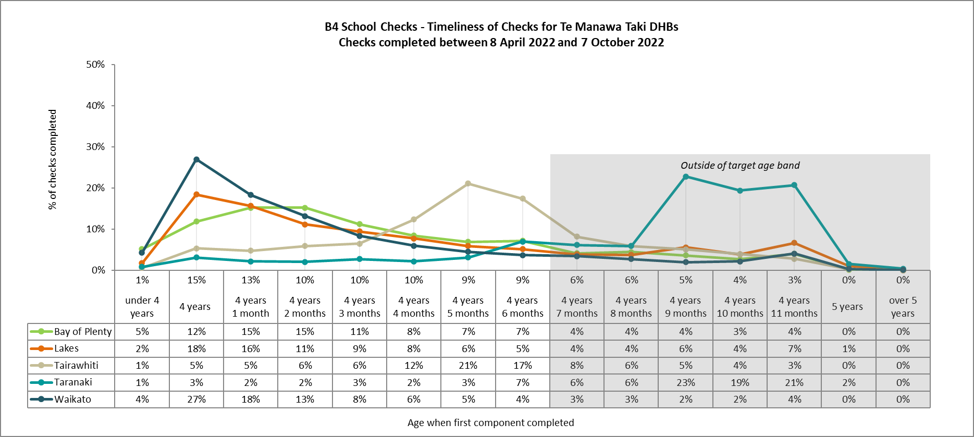

Definitions:

***DHB***: the DHB currently associated with the completed check

***Age Band***: the age of the child in completed months when the first component of the B4SC check is completed. The B4SC component checks are general, vision, hearing, dental, immunisation, peds, sdqp, sdqt, growth.

**The date of completion of the first component of B4SC check is calculated as**: min (vision date completed, vision date closed, hearing date completed, hearing date closed, general date completed, general date closed, growth date completed, growth date closed, dental date completed, dental date closed, imms date completed, imms date closed, ped date completed, ped date closed, sdqp date completed, sdqp date closed, sdqt date completed, sdqt date closed)

***Target Age Band:*** the target age of the child in completed months when the first component of the B4SC check is completed should be less than equal to 4 years and 5 months.

***Completed Checks***: Checks where the caregiver has given consent and the check <Date First Completed> is within the report period.

***Within Target Age Band Percentage***: the proportion of the completed checks where the age of the child at completion of the first component check is less than or equal to 4 years 5 months.

## Percentage of children who missed having first B4SC check by target age

The percentages of children who did not receive their first B4SC check by 4½ years of age, in the last three months, is shown below:

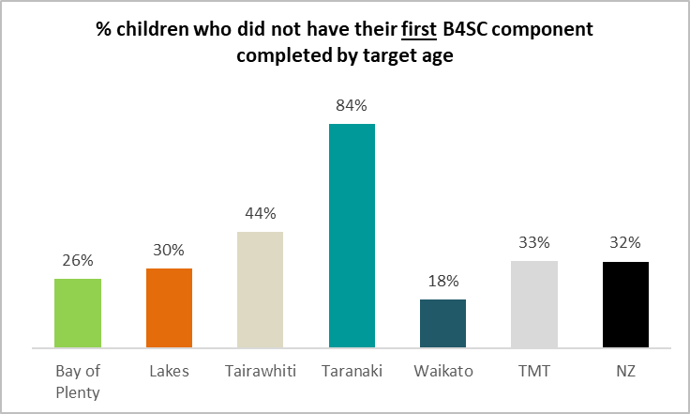

## Before School Checks completed by ethnicity

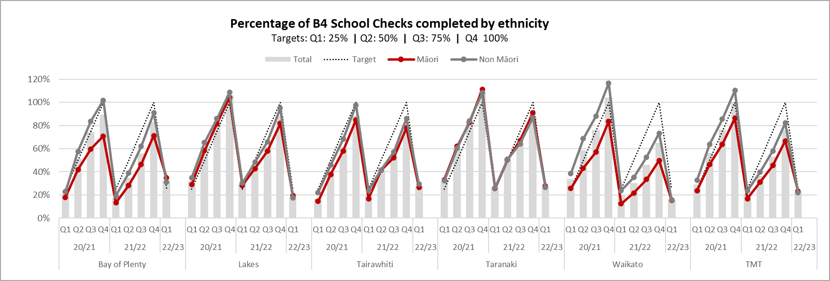

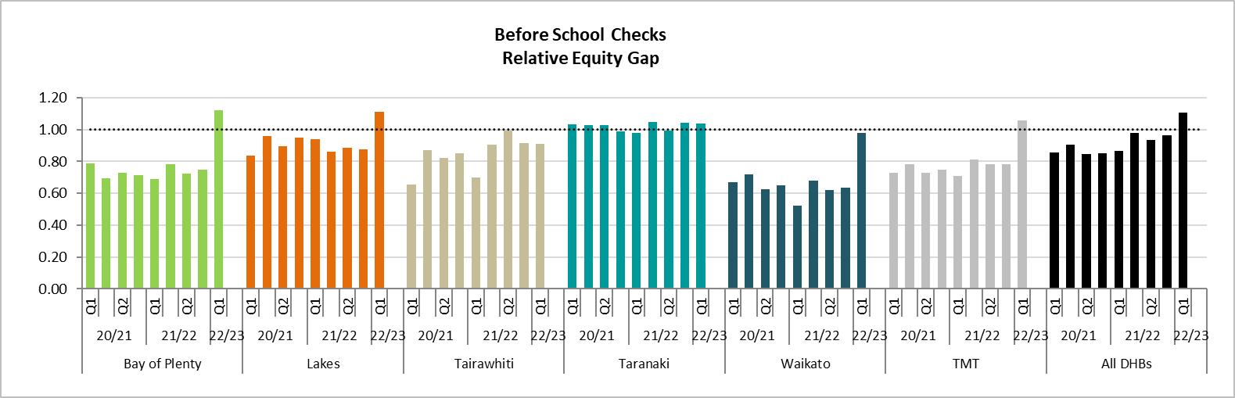

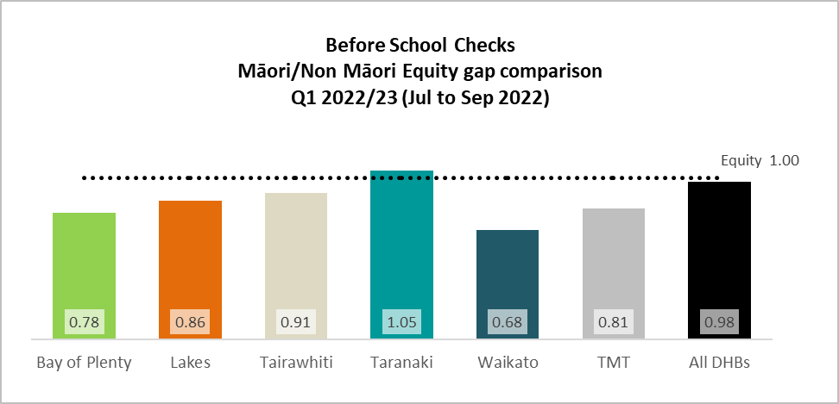

# Childhood Obesity

From Q3 2020/21, all B4SC obesity data previously provided in this report is now provided in the embedded Excel file below.

**B4SC Obesity results:**



Data Source: Ministry of Health: B4SC report – 7 October 2022

Definitions: Appendix 4.1

# Oral Health

## B4SC results

Full results are provided in the embedded document below, including full DHB rankings for decay level 2-6 and, of this group, those that are under care.

From Q1 2020/21, rankings are provided for current and historical reporting quarter, showing results for Te Manawa DHBs ranked against all DHBs for percentage of children with decay levels 2-6 and, of these children, the percentage who were under care. Results are provided in embedded file.

**B4SC oral health results:**



Data Source: Ministry of Health: B4SC report – 7 October 2022

## Oral Health Results for Children Aged Five Years and Year 8 (CW01 & CW02)

The following oral health report covers data relating to children aged five years and year 8 children (12/13 years). The results have been sourced from MOH Policy Priority results (CW01 and CW02) reported annually by DHBs to Ministry of Health in March each year, covering results from the previous calendar year. Data takes one to two years to be published.

The report covers a variety of results by DHB, ethnicity and fluoridation status:

1. % children caries free
2. Mean DMFT for all children aged 5 years/Year 8 and children with caries aged 5 years/Year 8
3. Equity gap results – measuring Māori and Pacific results against ‘Other’

**Please read the notes below before opening embedded spreadsheet**



**Notes to Report**

1. When reading or sharing this information the following points must be considered:
2. Fluoridation status has not been included. There are several variables that blur the distinction between a fluoridated child and an unfluoridated child, including:

* Fluoridation status being defined by a child’s school location, rather than where they live (eg children whose home is not on a town water supply but attend school within a fluoride region).
* Fluoride varnish being provided to children recorded as unfluoridated due to their school’s location. The percentage of children who receive this treatment is not recorded in source data.
* Recent changes in fluoridation status (eg moving towns) are not able to be accounted for.

These variables prevent an accurate depiction of fluoridated versus unfluoridated results and it is therefore inappropriate to include a fluoridation breakdown in this report.

1. The source data does not separately identify children who consume high levels of sugary sweetened beverages (SSB). High SSB consumption may affect fluoridated/unfluoridated results. Ideally the source data would show a further breakdown of results for by high/low SSB consumption to enable analysis of this additional influence on oral health.
2. The source is not broken down by deprivation, which may also influence outcomes.
3. **Caries free** and **Decayed, Missing, Filled Teeth (DMFT)** results must be read and reported together to provide a complete picture to the reader.
4. The data is limited by the level at which it is reported annually by the DHBs to MOH (age 5/year 8, ethnicity).
5. Assumptions deeper than the level of data provided should not be made.  Analysis of lower level data is required to determine the individual and collective impact of fluoridation status, geographical location, deprivation, high SSB consumption, and ethnicity, and the influence these factors have on caries free and DMFT results.  The additional protective effect of fluoridated water may not be as apparent in economically advantaged communities e.g. Wainui Beach, under Tairāwhiti DHB, which is a low deprivation and non fluoridated community.
6. Factors outside the scope of this report may influence results:

* Geographical distribution of clinical services (including mobile services) during reporting period – are there any black spots where coverage is poor?
* Geographical distribution of DNAs
* Distribution of dental therapist/assistant clinical FTE – are some regional areas under/over serviced?
* Regional variance in contact hours, session length, number of visits per child (Decile based)
* Travel time for mobile services and the potential for reductions in contact hours in some areas

1. Due to low numbers, Tairāwhiti has included Pacific children under Other.
2. Lakes’ 2014 and 2015 raw results provided to MOH (eg count of children seen, number of Māori/Other, Pacific) are notably lower than other years, due to the removal of a number of children who hadn’t been attributed a fluoridation status and were unable to be included in the data reported to MOH as a result. Although the raw results are lower for these two years, the graphs in the embedded report still reflect the percentage, mean and relative equity gap results based on the reduced headcount.
3. The results are based on PP10 and PP11 quarterly reporting from DHBs to the Ministry of Health, these results are available publicly on the Ministry of Health website.

### Children Aged Five Years (CW01)

Taken from *Performance Measures 2020/21, Nationwide Service Framework Library:*

***Numerator****: At the first examination after the child has turned five years, but before their sixth birthday, the total number of children who are caries-free (Decay-free)*

***Denominator****: The total number of children who have been examined in the 5-year old age group, in the year to which the reporting relates.*

***Data source:*** *DHB via COHS and other oral health providers*

***Other components of this indicator:***

1. The data reported in the ***Numerator*** and ***Denominator*** must also be broken down by:

Ethnicity, using “prioritised ethnicity” approach[1] into the following (in order of assignment):

* 1. Māori;
  2. Pacific
  3. Other, and

1. water fluoridation status of the school area the child attends, defined as:
   1. fluoridated; and
   2. non-fluoridated.
2. The data for this indicator will be generated by DHBs. There is a number of technical interpretation issues associated with oral health, which are centred largely around variances in:
3. processes for data collection amongst DHBs
4. technologies for management of data amongst DHBs.
5. DHBs are encouraged to record data at the unit (individual child) level, using the National Health Index, but data are reported in an aggregated format and should be provided using the Ministry of Health Excel template, available on the quarterly reporting database or from the Ministry’s Oral Health Team.
6. DHBs are required to separately report the number of decayed, missing (due to caries), or filled teeth (dmft).

### Children At Year 8 - 12/13 Years (CW02)

Taken from *Performance Measures 2020/21, Nationwide Service Framework Library:*

***Numerator****: Upon the commencement of dental care, at the last dental examination before the child leaves the DHB’s Community Oral Health Service, the total number of:*

*i) permanent teeth of children in school Year 8 (12/13-year olds) that are:*

* *Decayed (D),*
* *Missing (due to caries, M), and*
* *Filled (F); and*

*ii) children who are caries-free (Decay-free)*

***Denominator****: The total number of children who have been examined in the Year 8 (12/13-year olds) group, in the year to which the reporting relates.*

***Data source:*** *DHB via COHS and other oral health providers*

**Other components of this indicator:**

1. The data reported in the **Numerator** and **Denominator** must also be broken down by:
2. Ethnicity, using “prioritised ethnicity” approach[2] into the following (in order of assignment):
   1. Māori;
   2. Pacific
   3. Other, and
3. water fluoridation status of the school area the child attends, defined as:
   1. fluoridated; and
   2. non-fluoridated.
4. The data for this indicator will be generated by DHBs. There is a number of technical interpretation issues associated with oral health, which are centred largely around variances in:
5. processes for data collection amongst DHBs
6. technologies for management of data amongst DHBs.
7. DHBs are encouraged to record data at the unit (individual child) level, using the National Health Index, but data are reported in an aggregated format and should be provided using the Ministry of Health Excel template, available on the quarterly reporting database or from the Ministry of Health’s Oral Health Team.
8. DHBs are required to separately report the number of Decayed, Missing (due to caries), or Filled teeth (as well as total DMFT).

# Maternity Clinical Indicators

MOH publish the Maternity Clinical Indicators annually, with latest results being 2019, published May 2022.

MOH advise that:

*“This report presents comparative maternity interventions and outcomes data for pregnant women and their babies by maternity facility and district health board region. It presents 20 indicators that reflect care during pregnancy and the postnatal period, severe maternal morbidity and outcomes for babies at birth.*

* *One applies to women who registered with a lead maternity carer (LMC).*
* *Eight apply to standard primiparae (definition used to identify a group of women for whom interventions and outcomes should be similar).*
* *Seven apply to all women giving birth in New Zealand.*
* *Four apply to all babies born in New Zealand.”*

The embedded file below provides:

* Maternity clinical source data from 2011-2018 (numbers and percentages) for each Te Manawa Taki DHB and NZ, by Asian, European/Other, Indian, Pacific, Māori, Non Māori, and Total ethnicities
* Graphs displaying 2011-2018 results (%) for Māori, Non Māori and Total for each Te Manawa Taki DHB against New Zealand results
* Absolute and relative equity gap results for 2011-2018 for Māori/Non Māori results for each Te Manawa Taki DHB

**Maternity Clinical Indicators 2012-2019:**



New Zealand Maternity Clinical Indicators 2018 – background document:



# Maternal Smoking

As of Q3 2020/21 the smoking results for the following measures have been moved to the appendices, due to regional results not being able to be obtained for 2020/21.

* Percentage of pregnant women who identify as smokers upon registration with LMC or DHB based midwife
* Health Target: Pregnant women given brief advice and support to quit smoking

These measures will be brought back into the body of the report, if and when results become available to HealthShare.

System Level Measure and Maternity Clinical Indicator related smoking results continue to be published on the following pages.

## Babies living in smokefree homes – System Level Measure (SLM)

The WCTO measure for babies living in smokefree homes was shifted to a system level measure in 2018.

Six monthly results as published in the Nationwide Service Framework Library are provided below:

|  |  |  |
| --- | --- | --- |
| **Year** | **Jul to Dec** | **Jan to Jun** |
| 2017/18 |  |  |
| 2018/19 |  |  |
| 2019/20 |  |  |
| 2020/21 |  |  |
| 2021/22 |  |  |

This information is also available via:

<https://nsfl.health.govt.nz/dhb-planning-package/system-level-measures-framework/data-support-system-level-measures/babies>

## Maternity Clinical Indicator: Maternal tobacco use at two weeks postnatal

This indicator monitors maternal tobacco use at two weeks postnatal, which potentially identifies the number of women who have continued to smoke during pregnancy and following the birth as well as those who have re-commenced smoking following the birth. Results are based on DHB of residence.

Annual data is currently available up to the 2020 calendar year.

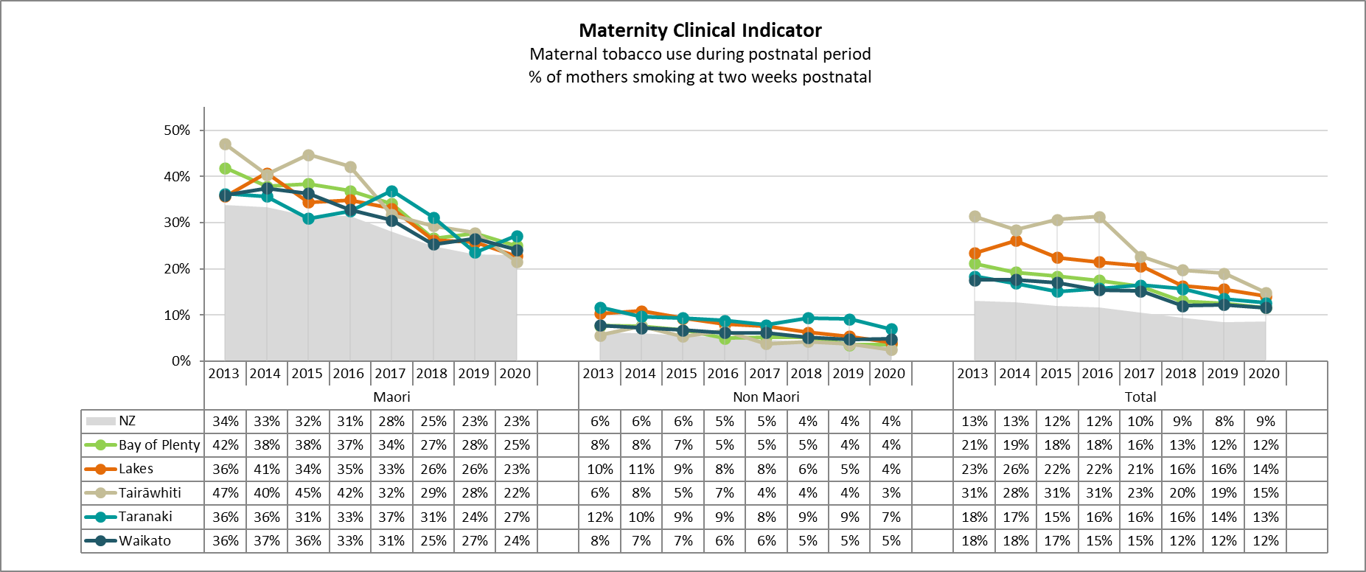

*Data source: MOH Maternity Clinical Indicators (sourced from National Maternity Dataset) -* [*http://www.health.govt.nz/search/results/maternity%20indicators*](http://www.health.govt.nz/search/results/maternity%20indicators)

### Relative Gap

“If the picket fence hasn’t reached the rail at 1.00, the Māori result is poorer than the Non Māori result”

**Picket Fence**

The relative gap also shows a significant relational difference between Māori and Non Māori results (*Non Māori ÷ Māori*) throughout Te Manawa Taki and New Zealand, with Māori recording much poorer results in relation to Non Māori. Improvement of low results will be indicated by an upwards trend upwards towards 1.00 and higher.

***The relative gap shows the relationship between Māori and Non Māori referral rates***

*Non Māori ÷ Māori*

***Desired trend is upwards***

***Desired result is 1.0 or greater***

ü

*Results >1.0*

*Māori rates are better than Non Māori rates*

*……………………………………………………………...….*

û

*Results <1.0*

*Māori rates are poorer than Non Māori rates*

*If absolute gap is 1.0 then Māori and Non Māori results are the same*

*Note: equity gap calculation is reversed due to target goal being less than target*

Results below 1.00 indicate a weaker outcome for Māori than Non Māori, at 1.00 there is equity between the two groups’ results and above 1.00 indicates a stronger outcome for Māori than Non Māori.

*Data source: MOH Maternity Clinical Indicators (sourced from National Maternity Dataset)*

[*http://www.health.govt.nz/search/results/maternity%20indicators*](http://www.health.govt.nz/search/results/maternity%20indicators)

*For further information re absolute and relative equity gaps – refer to Equity Gap – Working Example –in* *Appendix 3.0*

# Immunisation

With the availability of immunisation results via the Ministry Qlik website, a comprehensive collection of results for all milestone ages can now be provided in the embedded spreadsheets below.

* Quarterly results
* Equity Gap – Absolute and Relative
* How many to reach target
* Timeliness
* DHB rankings
* Results by region
* Opted off/Declined and Missed – results and equity gaps

**1. Quarterly Results**



**2. Annual Results (updated each quarter)**



# Ambulatory Sensitive Hospitalisations (ASH)

### Annual results

The following embedded information provides the latest annual Ambulatory Sensitive Hospitalisation (ASH) results for each Te Manawa Taki DHB.

**ASH results:**



Data Source: http://nsfl.health.govt.nz/accountability/performance-and-monitoring/data-quarterly-reports-and-reporting/ambulatory-sensitive

# APPENDICES

# Te Manawa Taki Population and Demography

## 2021/22 Projected Population - 0-19 years

Te Manawa Taki’s projected population figures for 2021/22 are:

TMT child health (0-19 years) population is 265,845 which equates to 26.4% of New Zealand’s child health population (1,007,405):

Data source: 2018 Census Survey 2020 Update - Stats NZ Population Projections file, sourced from Ministry of Health – updated January 2021

## Projected Population Change - 0-19 years

The change is child health population over the next 20 years is shown in the graph below.

Population projections provided by the Ministry of Health indicate the 0-19 years population will decrease by 9,095 (-3.4%) in 20 years’ time.

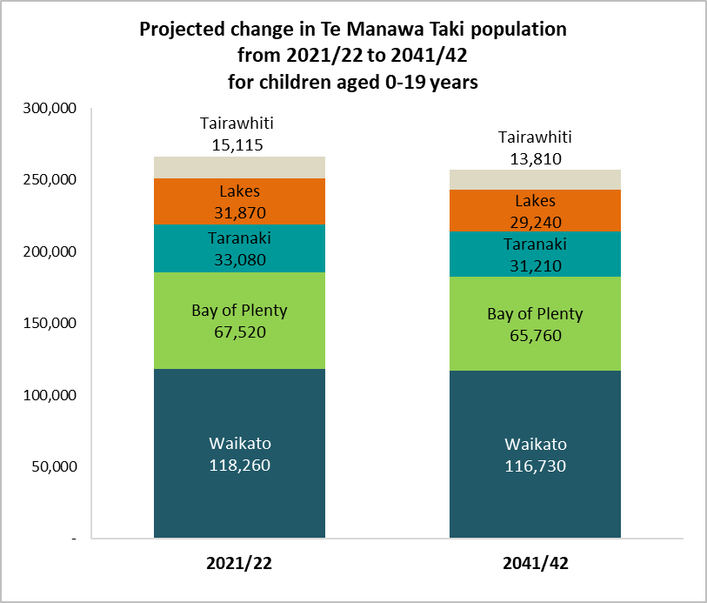

Data source: 2018 Census Survey 2020 Update - Stats NZ Population Projections file, sourced from Ministry of Health – updated January 2021

# Equity Gap – Worked Example

|  |  |  |  |  |  |
| --- | --- | --- | --- | --- | --- |
| **Equity Gap - worked example** | | |  |  |  |
|  |  |  |  |  |  |
|  | Where target is to achieve 100% | |  |  |  |
|  | **DHB** | **Māori** | **Non Māori** |  |  |
|  | DHB1 | 5% | 25% |  | *Māori result is* ***lower*** *than Non Māori result* |
|  | DHB2 | 15% | 35% |
|  | DHB3 | 25% | 45% |
|  | DHB4 | 35% | 55% |
|  | DHB5 | 45% | 65% |
|  | DHB6 | 100% | 80% |  | *Māori result is* ***higher*** *than Non Māori result* |
|  | DHB7 | 90% | 70% |
|  | DHB8 | 80% | 60% |
|  | DHB9 | 70% | 50% |
|  | DHB10 | 60% | 40% |

How this data is often graphed:

This graph does not easily show the equity gap between Māori and Non Māori results, in particular the trends in equity gap over time.

The following pages show two useful ways of showing the equity gap alongside the graph above.

**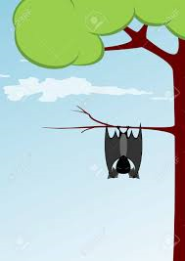******

If the results are hanging downwards **“like a bat”** Māori are achieving a poorer result than Non Māori.

Note to analysts: if reporting a result where the goal is to stay below target rather than above, switch your calculation to **Non Māori less Māori** and the absolute equity gap results will be displayed in the same context as the graph above (ie poorer result for Māori will be hanging like a bat)

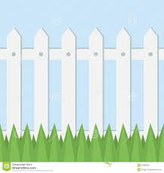

If the **“pickets” on the “fence” haven’t reached the “rail” at 1.0**, Māori are achieving a poorer result than Non Māori.

Note to analysts: if reporting a result where the goal is to stay below target rather than above, switch your calculation to **Non Māori ÷ Māori** and the absolute equity gap results will be displayed in the same context as the graph above (ie poorer result for Māori will be hanging like a bat

If the results have not reached the rail of the **“picket fence”** (at 1.00) Māori are achieving a poorer result than Non Māori.

Note to analysts: if reporting a result where the goal is to stay below target rather than above, switch your calculation to **Non Māori ÷Māori** and the relative equity gap results will be displayed in the same context as the graph above (ie poorer result for Māori will be below the rail of the picket fence)

## Which option is better?

In the example provided in this section, the absolute graph reflects the consistent 20% difference between the raw results below, where the relative gap provides insight into the relationship between the two results.

|  |  |  |  |  |  |  |  |  |  |  |  |  |  |  |  |  |
| --- | --- | --- | --- | --- | --- | --- | --- | --- | --- | --- | --- | --- | --- | --- | --- | --- |
| **Equity Gap - worked example** | | | |  | | |  |  |  |  |  | | | | |  |
|  | **DHB** | **Māori** | **Non Māori** | |  | **Absolute equity**  *Māori % less Non Māori %* | | | | | | **Absolute Equity Gap** |  | **Relative equity**  *Māori % ÷ Non Māori %* | **Relative Equity Gap** |
|  | DHB1 | 5% | 25% | |  | 5% less 25% | | | | | | (20%) |  | 5% ÷ 25% | 0.20 |
|  | DHB2 | 15% | 35% | |  | 15% less 35% | | | | | | (20%) |  | 15% ÷ 35% | 0.43 |
|  | DHB3 | 25% | 45% | |  | 25% less 45% | | | | | | (20%) |  | 25% ÷ 45% | 0.56 |
|  | DHB4 | 35% | 55% | |  | 35% less 55% | | | | | | (20%) |  | 35% ÷ 55% | 0.64 |
|  | DHB5 | 45% | 65% | |  | 45% less 65% | | | | | | (20%) |  | 45% ÷ 65% | 0.69 |
|  | DHB6 | 100% | 80% | |  | 100% less 80% | | | | | | 20% |  | 100% ÷ 80% | 1.25 |
|  | DHB7 | 90% | 70% | |  | 90% less 70% | | | | | | 20% |  | 90% ÷ 70% | 1.29 |
|  | DHB8 | 80% | 60% | |  | 80% less 60% | | | | | | 20% |  | 80% ÷ 60% | 1.33 |
|  | DHB9 | 70% | 50% | |  | 70% less 50% | | | | | | 20% |  | 70% ÷ 50% | 1.40 |
|  | DHB10 | 60% | 40% | |  | 60% less 40% | | | | | | 20% |  | 60% ÷ 40% | 1.50 |
|  |  |  |  | |  | Across the board 20% result does not fully reflect the relationship between the pairs of results:  *DHB1: Māori 5% result needs to be multiplied by 5 to reach the corresponding Non Māori result of 25% (5% x 5 = 25%)*  *DHB3: Māori result of 25% only needs to be multiplied by 1.8 to reach Non Māori result of 45% (25% x 1.8 = 45%)* | | | | | | |  | Results reflect the true relationship between the pairs of results:  *DHB1: 5% equates to 0.20 of 25% (5% ÷ 25% = 0.2)*  *DHB3: 25% equates to 0.56 of 45% (25% ÷ 45% = 0.56)* | |

## Equity gap reporting demonstrates trends over time

|  |  |
| --- | --- |
| Absolute Equity Gap |  |
| Relative Equity Gap |  |

The results below are the ones that produced the equity gap graphs on the previous page:

Equity gap results must be read alongside trend over time and results against target.  If both Māori and Non Māori record the same percentage their absolute and relative results will show as equitable but may still be a long way from achieving target (eg Māori = 20% and Non Māori = 20%, equity is demonstrated, but if target is 100%, both are doing poorly).

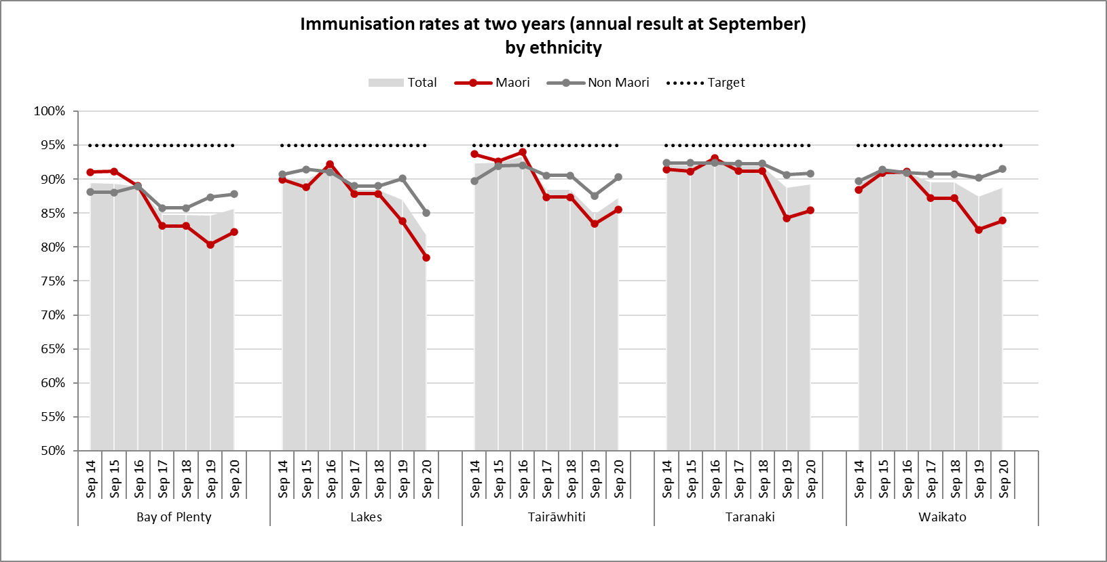

## Why use both absolute and relative equity measures in reporting?

To give context to results – absolute reporting is often used (and thought of) by default when showing equity, but relative reporting shows a more informative contrast between Māori and Non Māori results.

## Important – when to adjust the equity calculation:

The two equity gap calculation formulas vary depending on whether the goal is reach/exceed target or stay lower than target.  By manipulating the formula, equity graphs will provide a consistent visual result for the reader (downwards in absolute equity and under 1.00 in relative equity indicates a poorer result for Māori)

Where the goal is to **reach or exceed target** use the following calculation:

* Absolute equity:      Māori% - Non Māori%
* Relative equity:        Māori% ÷ Non Māori%

Where the goal is to **stay lower than target** use the following calculation:

* Absolute equity:      Non Māori% - Māori%
* Relative equity:        Non Māori% ÷ Māori%

### More information on absolute vs relative differences

Reference article with clinical example – risk of blindness



*Source:* [*http://ecp.acponline.org/janfeb00/primer.htm*](http://ecp.acponline.org/janfeb00/primer.htm)

# Supporting data

## B4SC Obesity definitions

**Definitions:**

*DHB*: the DHB currently associated with the completed check

***Ethnic Group:***

Three ethnicity fields (ethnicity1, ethnicity2, ethnicity3) are available in the B4SC system to capture ethnicity information for each child, with values assigned from the following ranked listing:

(1) NZ Māori, (2) Tokelauan, (3) Fijian, (4) Niuean, (5) Tongan, (6) Cook Islands Māori, (7) Samoan, (8) Other Pacific Island, (9) Pacific Island Not Further Defined, (10) South East Asian, (11) Indian, (12) Chinese , (13) Other Asian, (14) Asian Not Further Defined, (15) Latin American / Hispanic, (16) African, (17) Middle Eastern, (18) Other, (19) Other European, (20) European Not Further Defined, (21) New Zealand European/Pakeha, (22) Declined to State, (23) Not Stated

***Prioritised Ethnicity****:* The child's prioritised ethnicity is the value of ethnicity1, ethnicity2 or ethnicity3 which appears highest in the ranked listing above.

e.g. IF Ethnicity1 = Samoan (rank=7), Ethnicity2 = NZ Māori (rank=1), Ethnicity3 = New Zealand European/Pakeha (rank=21) THEN Prioritised Ethnicity = NZ Māori (rank=1)

***Ethnic Group:***Children in the B4SC system are assigned to ethnic groups: **Māori, Pacific, Other** based on their prioritised ethnicity.

> If Prioritised Ethnicity rank = 1 => Ethnic Group = NZ Māori

> If Prioritised Ethnicity rank in (2-9) => Ethnic Group = Pacific

> If Prioritised Ethnicity rank in (10-23) => Ethnic Group = Other

***Growth Checks Completed***: Checks that meet all of the following four criteria:

(1) Checks with a <Date First Completed> during the report period. Note that <Date First Completed> is the first date on which *all* components of the B4SC are completed.

(2) <Growth Date Measured> is recorded and occurs while the child is aged between the age of 48 and 60 months,

(3) Both <Growth height> and <Growth weight> are recorded,

(4) The child's calculated BMI is between 5 and 60 (to remove checks with obvious growth measurement errors)

Note that it is *not* necessary that <Growth Date Measured> also occurs within the report period.

***Children Obese and Over***: Children associated with Growth Checks Completed that have a calculated BMI that is >98th percentile, based on WHO Child Growth Standards.

Percent Children Obese and Over = Children Obese and Over / Growth Checks Completed.

***Referral Outcomes***: All Children identified as Obese and Over from Completed Growth Checks are assigned to one of the following referral outcomes, based on the methodology below:

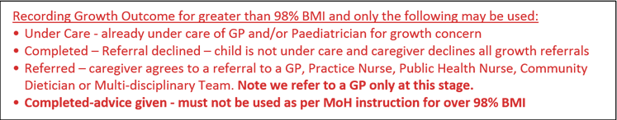 (1) Referral Acknowledged, (2) Referral Sent and not Acknowledged, (3) Under care, (4) Referral Declined, (5) Not Referred,

> ***Referral Acknowledged***: a growth referral for the child is sent to a recognised health professional and is acknowledged within the required timeframe.

> ***Referral Sent and Not Acknowledged***: a growth referral for the child is sent to a recognised health professional and is not acknowledged within the required timeframe.

> ***Under care***: no growth referral is sent to a recognised health professional, and the growth check outcome is 'Under care'

> ***Referral Declined***: no growth referral is sent to a recognised health professional, and the growth check outcome is 'Completed - Referral Declined'

> ***Not Referred***: no growth referral is sent to a recognised health professional, and the growth check outcome is other than 'Under care' or 'Completed - Referral Declined’ Not **Referred** **is a practitioner Decision, no need for a referral so not part of the care plan**.

A growth referral is sent to a recognised health professional if either:

> the referral sent date is before 1 July 2016 **OR** the referral is sent to one of: General Practitioner, Community Dietician, Public health nurse, Practice nurse, or Multi-disciplinary team

A growth referral acknowledged within the required timeframe if either:

> the referral sent date is before 1 July 2016 and referral acknowledgement date is within 60 days of referral sent **OR** referral acknowledgement date is within 30 days of referral sent

***Health Target Rate***: The proportion of children identified as obese and over for whom the DHBs apply the appropriate referral process for further assessment/intervention.

Calculated using the numbers of children obese and over assigned to each of the referral outcome groups.

= sum (Referral Acknowledged, Under Care, Referral Declined)/sum (Referral Acknowledged, Referral Sent and not Acknowledged, Under Care, Referral Declined, Not Referred)

***Referral Decline Rate***: The number of children identified as obese and over with a referral Declined as a percentage of those with a referral offered.

= sum (Referral Declined)/sum (Referral Acknowledged, Referral Sent and not Acknowledged, Referral Declined, Not Referred-Referral refused by service provider)

|  |
| --- |
| A growth referral acknowledged within the required timeframe if either: |
| > the referral sent date is before 1 July 2016 and referral acknowledgement date is within 60 days of referral sent **OR** referral acknowledgement date is within 30 days of referral sent |
| ***Health Target Rate***: The proportion of children identified as obese and over for whom the DHBs apply the appropriate referral process for further assessment/intervention. |
| Calculated using the numbers of children obese and over assigned to each of the referral outcome groups. |
| *= sum (Referral Acknowledged, Under Care, Referral Declined)/sum (Referral Acknowledged, Referral Sent and not Acknowledged, Under Care, Referral Declined, Not Referred)* |
| ***Referral Decline Rate***: The number of children identified as obese and over with a referral Declined as a percentage of those with a referral offered. |
| *= sum (Referral Declined)/sum (Referral Acknowledged, Referral Sent and not Acknowledged, Referral Declined, Not Referred-Referral refused by service provider)* |

1. It is acknowledged that use of the “prioritised ethnicity” approach is not consistent with New Zealand’s [Statistical Standard for Ethnicity](http://www.stats.govt.nz/~/media/statistics/class-stnd/ethnicity/ethnic05-statistical-standard.aspx); but it is considered that this approach is acceptable given that:

   the historical use of this approach in the long-term data series since 1990 and

   the standard “total response” approach will not provide an accurate picture of the number of children examined by DHBs’ Community Oral Health Service and other contracted third party providers.
2. It is acknowledged that use of the “prioritised ethnicity” approach is not consistent with New Zealand’s [Statistical Standard for Ethnicity](http://www.stats.govt.nz/~/media/statistics/class-stnd/ethnicity/ethnic05-statistical-standard.aspx); but it is considered that this approach is acceptable given that:

   the historical use of this approach in the long-term data series since 1990 and

   the standard “total response” approach will not provide an accurate picture of the number of children examined by DHBs’ Community Oral Health Service and other contracted third party providers.